AUTOMATIC DRUG DISPENSER
Overview:
The Automatic Drug Dispenser is a system designed to streamline the medicine dispensing process by utilizing QR codes. This system aims to enhance efficiency and accuracy in medication distribution by connecting patients, doctors, and pharmacies.
Features:
- QR Code Scanning: The dispenser reads QR codes containing prescription information.
- Email Integration: Patients receive QR codes via email, ensuring secure and convenient delivery.
- Medication Database: A comprehensive database stores medication details, ensuring accurate dispensing. (In our model we have used 5 medicines: Dolo, Meftal, Dulcoflex, Cetirizine, Azithromycin as basic)
- User Authentication: Secure user authentication prevents unauthorized access to prescription information.
- Dispensing Mechanism: Reliable dispensing system ensures precise delivery of prescribed medications.
Components:
1. QR Code Scanner Module (Raspberry PI)
- Responsible for reading QR codes containing prescription details.
- Interfaces with the central server to fetch prescription information.
2. Email Integration Module (node mailer)
- Manages the delivery of QR codes to patients via email.
- Ensures secure transmission of sensitive prescription information.
3. Medication Database
- Centralized database containing medication details and prescription information.
- Enables real-time access to accurate medication data.
4. User Authentication Module
- Implements a secure authentication process for doctors, patients, and pharmacies.
- Safeguards sensitive prescription data.
5. Dispensing Mechanism
- The physical unit responsible for dispensing the prescribed medications.
- Ensures precise and controlled release of medications.
Workflow
- Doctor's Prescription:
  - Doctor generates a prescription with medication details.
  - Prescription is converted into a QR code.
- Email Delivery:
  - QR code is sent to the patient via a secure email system.
- Patient Scanning:
  - Patient scans the QR code at the Automatic Drug Dispenser.
- Authentication:
  - System authenticates the patient and retrieves prescription details.
- Dispensing:
  - Dispenser releases the prescribed medications.
Security Measures
- Access Control: Strict user authentication prevents unauthorized access.
- Audit Trail: Logging mechanisms track system activity for accountability.

For better overview of the project, we have divided the project into two major parts SOFTWARE and HARDWARE. Which explains in detail about what are the technology stacks and hardware components used in making the project.

SOFTWARE PART
Technologies Used:
MERN stack
- MongoDB for Database which stores the Doctor details, Medicines, Prescription details.
- Express.js is a web application framework for Node.js, designed to simplify the process of building robust and scalable web applications and APIs. It provides a set of features and utilities for creating web and mobile applications, allowing developers to build server-side logic and handle HTTP requests and responses effectively.
- React.js, commonly referred to as React, is an open-source JavaScript library for building user interfaces or UI components. Developed and maintained by Facebook, react has gained widespread adoption in the web development community due to its efficiency, flexibility, and declarative approach to building UIs.
- Node.js is an open-source, cross-platform JavaScript runtime environment that allows developers to execute JavaScript code outside of a web browser. It is built on the V8 JavaScript runtime engine, which is the same engine that powers the Google Chrome browser. Node.js enables server-side scripting and the development of scalable and high-performance web applications.
BACKEND
Backend development is done by using express.js (framework), node.js and we have also used postman for testing, documenting, and managing APIs. Some of the key modules which we have installed for our project are:
QR Code module:
In Node.js, the qrcode module is a popular library used for generating QR codes. QR codes (Quick Response codes) are two-dimensional barcodes that can store various types of data, such as text, URLs, or other information. The qrcode module allows developers to create QR codes dynamically within their Node.js applications.
Nodemailer:
Nodemailer is a popular and widely used Node.js module that enables email sending capabilities in Node.js applications. It simplifies the process of sending emails through Node.js by providing an easy-to-use and feature-rich API. Nodemailer supports both traditional SMTP (Simple Mail Transfer Protocol) and other transport methods like sendmail and SES (Amazon Simple Email Service).

pdfkit is a Node.js module that allows you to create and manipulate PDF documents. It provides a simple and convenient way to generate PDF files using JavaScript. pdfkit is particularly useful for dynamically creating PDFs in server-side applications, such as generating reports or invoices.
Here are all the dependencies used:
"dependencies": {
"bcryptjs": "^2.4.3",
"cors": "^2.8.5",
"dotenv": "^16.3.1",
"express": "^4.18.2",
"google-auth-library": "^9.4.1",
"jsonwebtoken": "^9.0.2",
"mongoose": "^8.0.3",
"nodemailer": "^6.9.8",
"nodemon": "^3.0.2",
"pdfkit": "^0.14.0",
"qrcode": "^1.5.3",
"uuid": "^9.0.1"
}

DATABASE
In the database we will store the Doctor details using UserSchema and also Prescriptions filled by the doctor as prescriptionModel.
userSchema
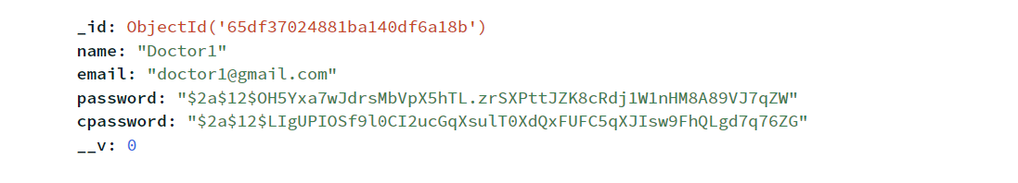

PresciptionModel:
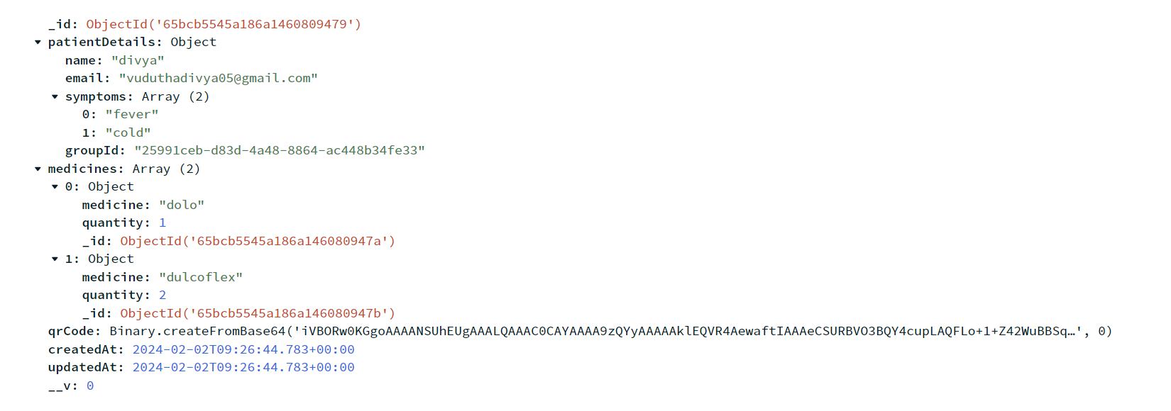
Here we are using proxy email to send the prescription to the registered mail of the patient the prescription is send in the form of pdf.
First look of the email sent:
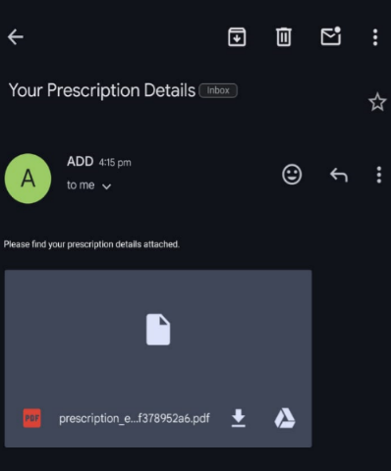

Details present inside the prescription:
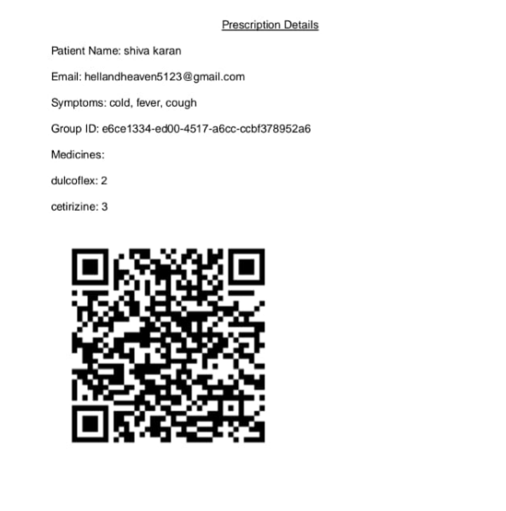

The pdf sent to the patient email is downloaded before it opens and saves in your internal memory. It has a unique Group ID .

FRONTEND
For frontend development we have used react.js and the applications will run in localhost:3000 the proxy localhost:5000 is used for backend running.
Bootstrap
It facilitates the development of responsive and visually appealing websites and web applications.
Navigation bar using bootstrap
HARDWARE PART
For building a machine we have used some equipment’s namely
1.Raspberry pi:
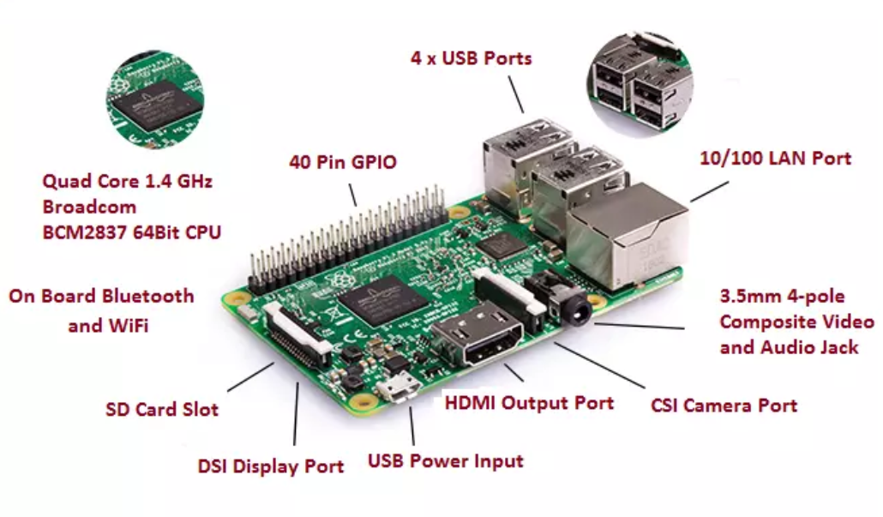
A raspberry pi is a credit card-sized single-board computer that runs on various operating systems, such as Raspbian. Its mostly popular for DIY projects serving as a versatile platform for tasks like automation and it supports hardware interfacing. We insert a SD card in the slot provided by installing the raspberry pi OS to it. An integral component of the raspberry pi’s appeal is its general-purpose input/output (GPIO) pins. These pins enable hardware interfacing, allowing users to connect the raspberry pi to plethora of sensors, actuators, and other electronic components.
2.Raspberry pi camera module v2
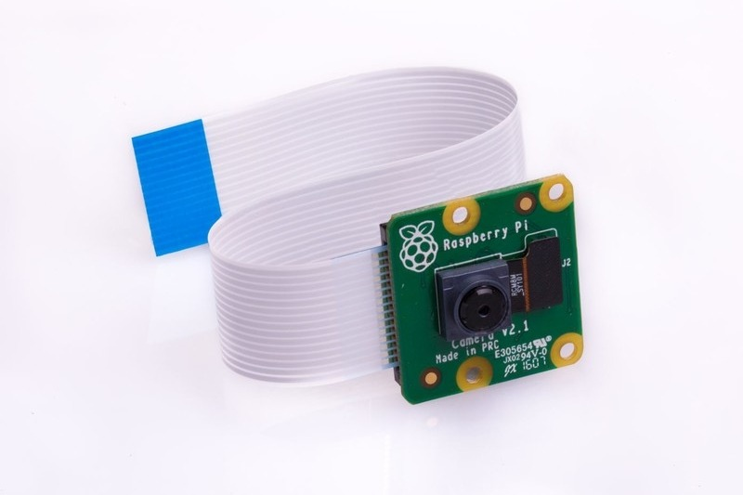
It is a compact and versatile imaging solution designed specifically for raspberry pi boards.

Key features:
1.High resolution:
8-megapixel sensor, providing a significant improvement in image quality compared to the earlier version.
2.Fixed Focus:
Simplifying the usage by eliminating the need for manual adjustments. Which makes it suitable for scenarios such as surveillance system or basic photography.
3.hardware support:
Supported by comprehensive set of libraries and API’s , including the official raspberry pi camera module python library.
3.Arduino nano
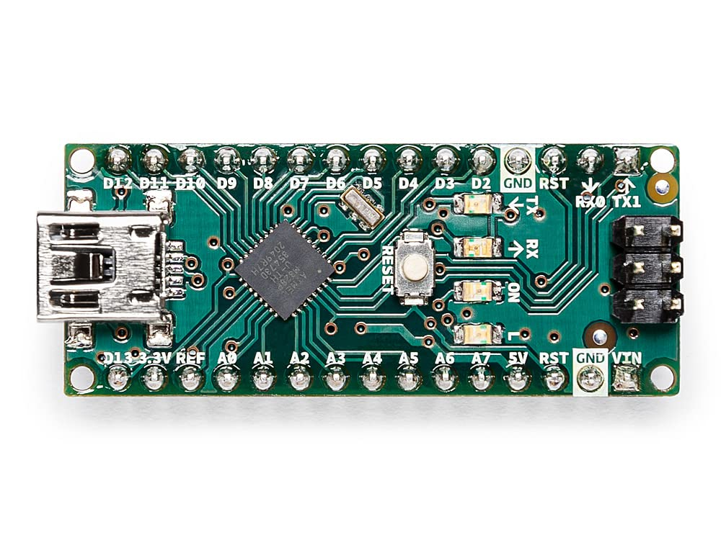
It is a microcontroller board which is powered by Atmel ATmega328 microcontroller, which is same microcontroller used in the Arduino Uno. It provides a good balance of processing power and capabilities for a wide array of applications. It has a considerable no of digital and analog pins, facilitating the connection of various electronic components.

4.Relay driver
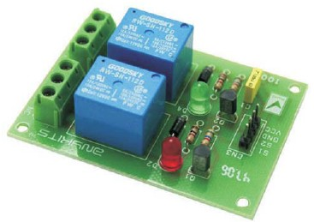
A Relay Driver is a circuit or device that controls a relay by providing the necessary current and voltage to activate it. It acts as an interface between microcontroller or low-power signal and high-power requirements of a relay, enabling the control of larger electrical loads using smaller control signals.
5.Vaccum pump
It is used to pick the medicines by applying the pressure when the motor is started and used to drop it when the motor is turned off and the pressure is reduced.
6.Motor
It is a electro-mechanical device that converts electrical energy into mechanical energy. It typically consists of coils, a rotor, and a stator. The motor generates suction by creating a airflow through the vacuum pipe. As the motor runs, it creates a low-pressure zone pulling air and debris through the pipe and into the vacuum pump. The suction power is crucial for effective picking and the motor’s ability to generate airflow plays a central role in vacuuming process.
7.IR sensor
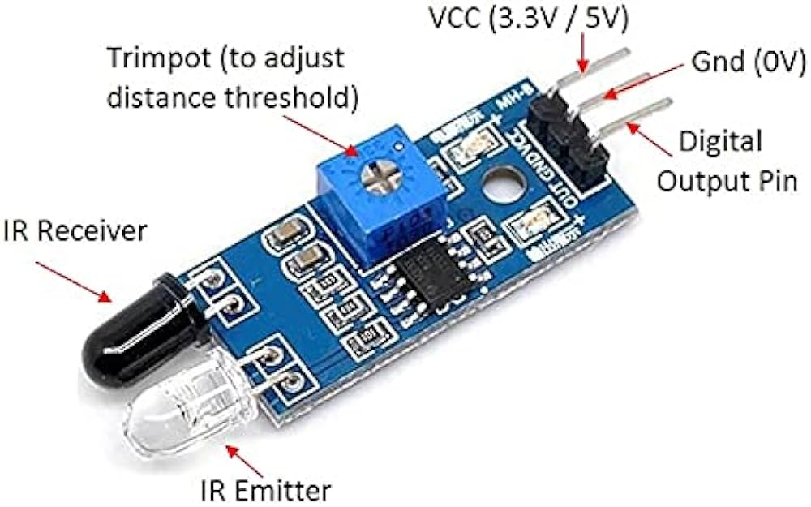
An Infrared (IR) sensor is a device that detects infrared radiation in its surrounding environment. It commonly consists of a IR transmitter and an IR receiver. The transmitter emits infrared light, if an object is in proximity, the reflected or emitted infrared radiation is detected by the receiver.
8.Stepper motors:
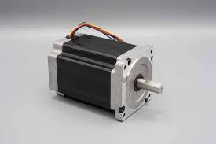
It is an electromechanical device that converts electrical pulses into discrete mechanical movements or steps. Its widely used in various applications like robotics, 3D printers provide precise control over position and rotation.
We require 3 stepper motors which are used to control the movement of x-axis y-axis and z-axis.
9.Stepper motor drivers:
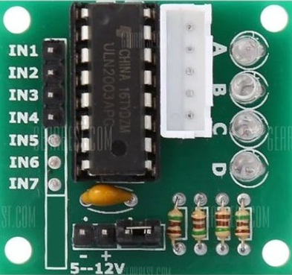
A stepper motor driver is an electronic device that controls the movement of a stepper motor by converting electrical pulses into precise mechanical motion. A stepper motor driver interprets digital signals from a controller and converts them into the necessary electrical current to drive the coils within a stepper motor.
10.CNC shield:
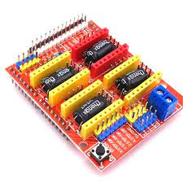
A CNC shield is a hardware component used in combination with an Arduino board to control stepper motors and other components in CNC systems.
One of the popular CNC shield is the GRBL.
- CNC shield contains slots for stepper motor drivers. Common drivers used with these shields are A4988 or DRV8825.
- These drivers control the movement of stepper motors used for precise positioning in CNC machines.
Connections
Separate relay connections with Arduino, power supply, vacuum pipe and motor.
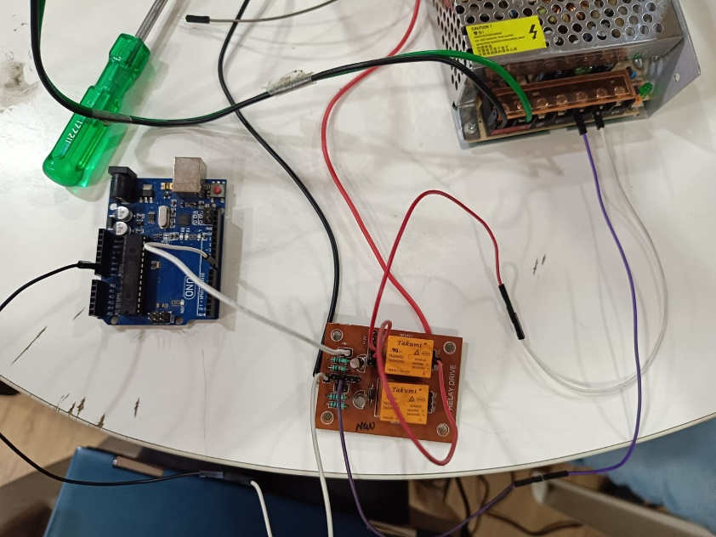
Relay controls the functionality of motor and it has separate power supply to on it required 12V power supply which cannot be given to both Arduino Nano and relay driver at once.
Arduino nano and raspberry pi connections:
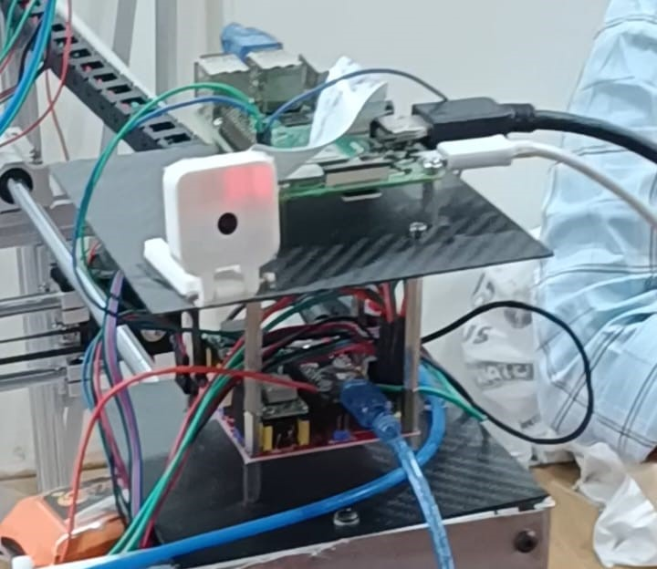
The blue wire shown in the image is used for serial communication between the raspberry pi and Arduino it is connected from the USB port of raspberry pi and a slot of c type in Arduino nano.
The white wire is used for power supply to the raspberry pi it needs power to start its functionality it cannot get power from the battery we are using to power up the Arduino nano it requires separate power supply.
Camera module v2 is connected to the CSI camera port to the raspberry pi.
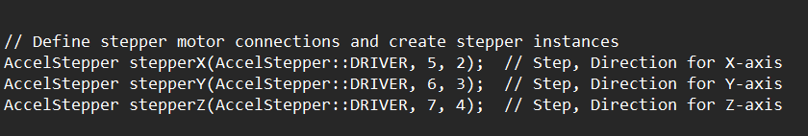
Stepper motor pins are declared in the code for the Arduino nano.
First number declared positive direction and the second declared negative direction of the motion.
IR sensor pin is connected to D13 of the Arduino nano.
Relay pin is connected to D12 of the Arduino nano.
Flow of commands in the machine:
An OS of raspberry pi is installed for operating.
1.Capturing the QR-Code
2.Decoding the information
3.Formatting the data
4.Sending the data to Arduino
5. Arduino receiving data from raspberry pi
6.Dispensing the medicines
We will now start to get to know how this machine functions:
1.Capturing the QR-Code:
Imports required for image capturing are
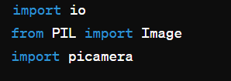
The io module in python provides the infrastructure for handling various types of I/O, including both text and binary data. In this case, ‘io.BytesI0’ is used to create an in-memory binary system.
The ‘Image’ class from the Python Imaging Library (PIL) is used to work with images in various formats. In this code, its specifically used to create an image object from the binary data captured to the raspberry pi camera.
The ‘picamera’ module provides an interface for interacting with raspberry pi camera.
The ‘Picamera’ class from ‘picamera’ is used to control the camera and capture images.
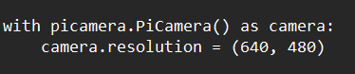
This block creates a picamera.Picamera instance and sets its resolution to 640x480 pixels.
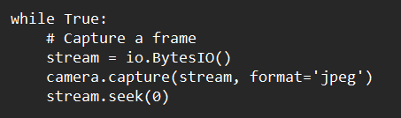
The ‘picamera’ library captures a frame from the camera and stores it in a binary stream(‘io.BytesI0’) rather than directly writing it to a file. This in-memory stream allows for efficient and flexible manipulation of binary data.
After capturing the frame, `stream.seek(0)` is used to move the stream’s position back to the beginning. This allows subsequent operations, such as decoding image or reading its content, to start from the beginning of the stream.
It is used for processing images captured by the raspberry pi camera without the need for intermediate files.
2.Decoding the information:
Imports required for decoding are
- This import statement brings in the decode function from pyzbar.pyzbar module.
- Pyzbar is a python library for reading barcodes, including QR codes.
- The decode function takes an image as input and returns a list of a decoded barcode objects.
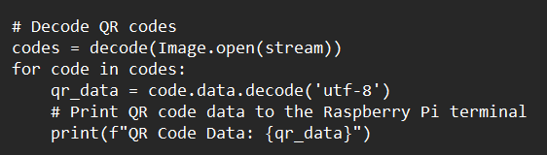
- Codes=decode(Image.open(stream)) this line uses decode function to decode QR-codes from the image opened from the binary system(‘stream’). The result is a list f barcode objects, each containing information about the detected QR-code.
- For code in codes: iterates the list of decoded codes.

Extracting QR code data:
qr_data=code.data.decode(‘utf-8’) Extracts the data from each decoded QR code and decodes it from bytes to a UTF-8 encoded string. This assumes that the QR code contains text data.
3.Formatting the data:
Json module is responsible for formatting the information into JSON format.
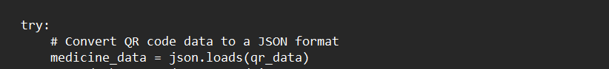
- The json.loads function is used to load(parse) a JSON-formatted string (‘qr_data’) and convert it into Python dictionary or list.
- `Medicine_data` is assigned the results of the JSON decoding.
4.Sending the data to Arduino:
Libraries we use for data transfer is serial
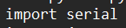
This module provides tools for working with serial ports, and it’s used for serial communication between raspberry pi and the Arduino.
Serial communication:
Involving exchanging data through a serial connection using UART (Universal Asynchronous Receiver/Transmitter) communication.
- Both raspberry pi and Arduino are equipped with UART hardware allowing them to communicate serially.
- Connect the TX(transmitter) pin of the Raspberry Pi to RX(receive) pin of the Arduino and vice versa.
- The baud rate (data transfer speed) must be configured consistently for both devices commonly include 9600,115200 etc.
- On the raspberry pi, the serial module is used in Python for serial communication. It can be installed using ‘Pip install pyserial’.
- Data is sent in sequence of bits, usually 8 bits per byte. Communication is asynchronous, meaning there’s no separate clock signal; both must agree on the baud rate.
- In raspberry Pi serial.Serial is used to open a serial connection.Data is end using write() method. Data can be received in the loop() function using Serial.available() and Serial.read().
This line initializes a serial connection with the Arduino
/dev/ttyUSB0 specifies the serial port on the raspberry pi to which the Arduino is connected. 9600 is the baud rate, specifying the speed of communication.
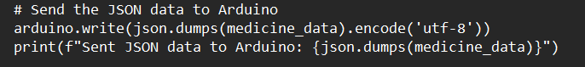
This line writes the serialized and UTF-8 encoded JSON data to the Arduino via the serial connection.
Json.dumps(medicine_data) converts the python data structure into a JSON-formatted string.
Encode(‘utf-8’) converts the string into a byte sequence using UTF-8 encoding which is suitable for serial communication.
Logging:
Importing logging module
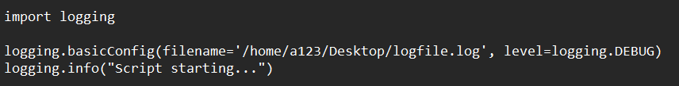
Logging is a process of recording events, actions or messages that occur during the execution of the program these messages specifically stored in a file which belongs to a folder it is used to analyse or monitor or debugging purposes.
In this we used logging method for monitoring of the execution of the raspberry pi code and to do changes if there are any problems occurs we can solve by checking the log files in our program we used “logfile.log” for monitoring the program.

5. Arduino receiving data from Raspberry pi
The serial.begin(9600) function initializes the serial communication at a baud rate of 9600.
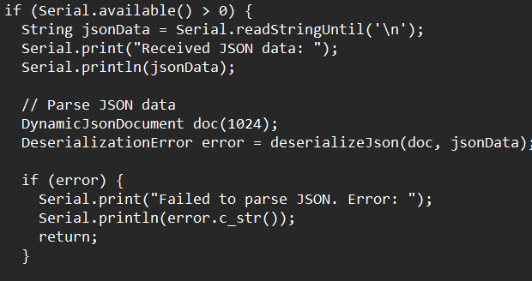
Serial Input:
- The serial.available() function is used to check if there is incoming serial data from the raspberry pi.
- If(serial.available()>0) checks if there is data available for reading.
Reading string data:
- Serial.readStringUntil(‘\n’) function reads a string from the serial input until it encounters a newline character(‘\n’).
- The received string is assumed to be in JSON format, is stored in jsonData variable.
JSON Parsing:
- Parsing is nothing but extracting meaningful information.
- The dynamicJsonDocument and deserialization function from the Arduino library are used for parsing JSON data.
- The received JSON data is parsed into a dynamic JSON document (‘doc’).

JSON array iteration:
- If the parsed JSON is in the form of array(‘doc.is<JsonArray>()’) the code iterates through each element of the array.
Extracting JSON Data:
line extracts individual fields from the JSON Array.
6.Dispensing the medicines
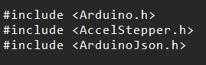
Declaration of coordinates:
We declared 5 coordinates which are stable coordinates where medicines are to be kept.
The decoded data is then compared with the function strcmp where key value pairs of medicine and number of strips are taken. 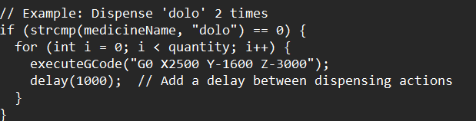
For example if the decoded data has dolo:2 then it will go check the if condition then it is true and it will check for how many times the iteration should take place where i=2 in the above case it will enter executeGcode function. The above coordinate is the fixed coordinate of the tablet Dolo.
For processing the coordinate the CNC shield processes the information.
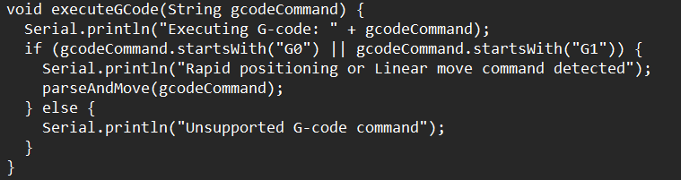
Here is the execute G-code function if coordinate starts with G0 or G1 then only parse and move function will execute.
Parse and move function we decode them step by step:
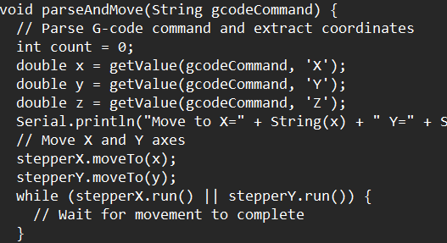
Here we have initialized the z-axis step count as 0, and get value function is used to extract the numerical values associated with specific letters(axes).
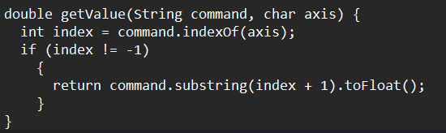
Then we move the x-axis and y-axis to there respective positions and for z-axis we are supposed to check for object detection.
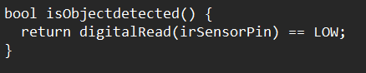
This function checks for the object detection if (IRsensorpin==low) then object detected. It returns true.
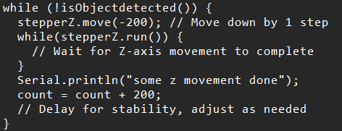
If the object is not detected the step count will get incremented by 200 steps. Until the object is detected it will move the z-axis.
After the object is detected the it will on the motor using relaypinlow
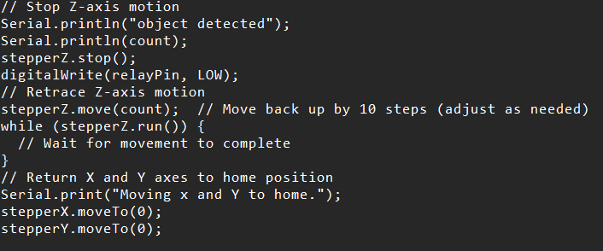
After the object is picked using the air-pressure of motor using vacuum it return to its home position if we initiate stepperX.move(0).
After it reaches its home position the (relaypin==high) and motor turn off and the medicines are dispensed through the machine.
Conclusion
The Automatic Drug Dispenser enhances the medication dispensing process by leveraging QR codes and email communication. With a robust system architecture and security measures, it aims to provide a seamless and secure experience for patients, doctors, and pharmacies.
Our dispensing machine reduces the risk of medication errors by automating the dispensing process. 24/7 availability. Reduces wait time for patients receiving outpatient prescriptions. Fast dispensing of medicines and accuracy.
References:
  - https://youtu.be/z13suX43TWY?si=Enp6tsyhg_wE5vXk we have taken reference of this model to build our machine.
  - https://youtu.be/m6aS9YF-0xo?si=O7xdFTid8NPU7FeS how can we set up and access a raspberry pi remotely.

